**Test Plan for Ataccama TestCalc application**

* 1. **Overview**
  2. **Test Environment for the UI tests**

According to <https://gs.statcounter.com/>, the most popular browser is Chrome (~70%). The following popular browser is Firefox (~10%). The UI tests will be run against Chrome and Firefox, and it will cover ~80% of all users.

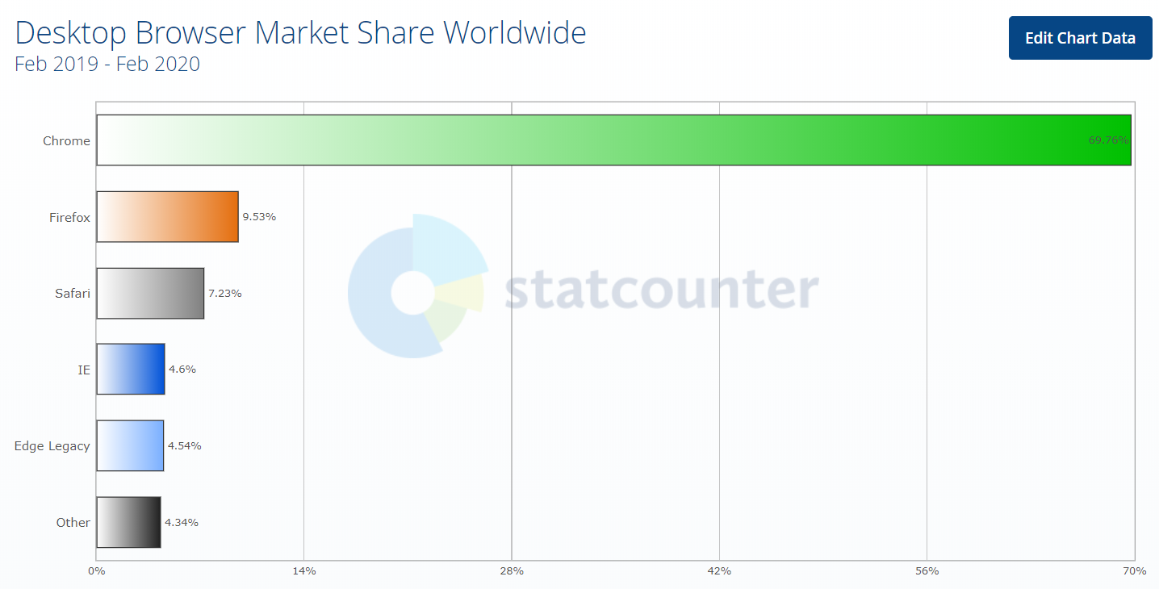

*Fig. 1.1. Desktop browser usage statistics*

* 1. **Choosing test parameters**

**Value1:** integer values from -2147483648 to 2147483647

**Value2:** integer values from -2147483648 to 2147483647

**Operations:** addition, subtraction, multiplication, division

The main challenge is to choose a valid set of test values to cover all risky combinations. To best way to achieve this is to use such Test Design techniques as Equivalence Partitioning and Boundary Value Analysis.

All data can be divided into the following equivalence classes:

1. **Below zero**. Values from -2147483648 to 1.
2. **Zero**. Contains only one value – 0.
3. **Above zero**. Values from 1 to 2147483647.
4. Integers with **leading zero**, e.g. 0000012345689 – zeroes should be removed automatically.

In addition, there can be considered а negative class, which contain values, causing the exception in the calculator.

1. **Negative**.

* -2147483649, 2147483648 – values out of integer range
* empty values
* non-integer values (e.g. 1.0)
* strings (e.g. “aBd%##@(%)@”)
* valid integers with trailing empty strings, e.g. “1111111 “
* zero division

Final classes set:

1. **Below zero**:

-2.147.483.648 boundary value

-46.340 $\sqrt{-2.147.483.648}$

-215 $\sqrt{46340}$

-15 $\sqrt{215}$

-1 boundary value

1. **Above zero**:

2.147.483.647 boundary value

46.340 $\sqrt{-2.147.483.647}$

215 $\sqrt{46340}$

15 $\sqrt{215}$

1. boundary value
2. **Zero:** 0
3. **Negative**:

-2147483649 Integer.MIN_VALUE - 1

2147483648 Integer.MAX_VALUE + 1

99.0 Non-integer

!@#$%^&*() as8o5 String

123 34 3 Invalid number with spaces

“ “ Empty string

* 1. **Pairwise Independent Combinatorial Testing**

For decreasing the number of test combinations was used **Pairwise Testing** technique.

Pairwise testing (a.k.a. all-pairs) is an effective test case generation technique that is based on the observation that most faults are caused by interactions of at most **two** factors.

Pairwise-generated test suites cover **all combinations** of two therefore are much smaller than exhaustive ones yet still very effective in finding defects.

For generating test parameters combinations was used tool PICT (Pairwise Independent Combinatorial Testing tool) by Microsoft. See models txt files in attachments.

*PICT model for positive combinations:*

**Operations**: addition, subtraction, multiplication, division

**Value1**: -2147483648, -46340, 215, 15, 1, 0, 2147483647, 46340, 215, 1

**Value2**: -2147483648, -46340, 215, 15, 1, 0, 2147483647, 46340, 215, 1

Generated combinations: 180

Generated tests: 100

*PICT model for negative combinations:*

**Operations**: addition, subtraction, multiplication, division

**Value**: -2147483649, 2147483648, 99.0, !@#$%^&*() as8o5, " "

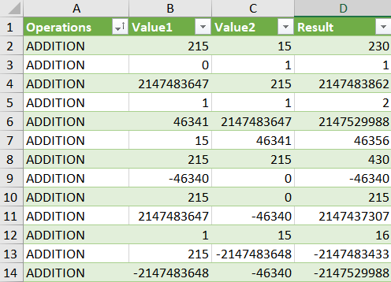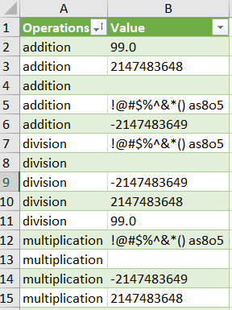

*Fig 1.3. Test data example*

In addition, for automated testing were used random values.

**NOTE**: Test data spreadsheet is stored in *src/tests/resources* folder.

* 1. **General Test Description**
* Performing math operations (addition, subtraction, division, multiplication).
* Verify absence of errors and exceptions in case of valid input values.
* Verify stability of the application.
* Record operation result. Compare with the result from the external calculator (e.g. Windows Calculator).

**1.5. Manual test cases examples**

*Preconditions for each test case*:

* Installed Apache Tomcat web server
* Application .war file stored into Tomcat\webapps folder
* Web server is launched and works correctly
* Installed the Chrome browser

**TC 1 - positive**

*Steps*:

1. Open the browser, go to URL <http://localhost:8080/testCalc/webUI>
2. Select **addition** radio button
3. Value1 🡪 Enter a valid integer number
4. Value2 🡪 Enter a valid integer number
5. Click **Calculate**

*Expected Results*:

1. Application launched successfully
2. Operation radio button selected
3. **Value1** populated successfully
4. **Value2** populated successfully
5. Calculated result is correct, there is no exceptions

Repeat the test for all generated positive test conditions

**TC 2 - negative**

*Steps*:

1. Open the browser, go to URL <http://localhost:8080/testCalc/webUI>
2. Select **multiplication** radio button
3. **Value1** 🡪 Enter invalid value (empty string, non-integer, too big value, etc.)
4. **Value2** 🡪 Enter a valid integer number
5. Click **Calculate**

*Expected Results*:

1. Application launched successfully
2. Operation radio button selected
3. **Value1** populated successfully
4. **Value2** populated successfully
5. There is the exception thrown. Verify the exception has a valid message.

Repeat the test for all generated negative test conditions

**2.0. Test Automation Approach**

**2.1. Technologies stack**

For the automation of the app was chosen **Java** as primary language. The main reason of this choice – the application under test also uses Java, and it has a lot of benefits, such as:

1. Same programming language fosters collaboration between developers and QA engineers.
2. Same programming language makes software environment setup easier: the same IDE, the same CI server, the same development environments, etc.

For the UI testing was used **Selenium WebDriver** <https://www.selenium.dev/>.

For the API testing was used **REST Assured** <http://rest-assured.io/>. This is a Java library that provides a domain-specific language (DSL) for writing powerful, maintainable tests for RESTful APIs.

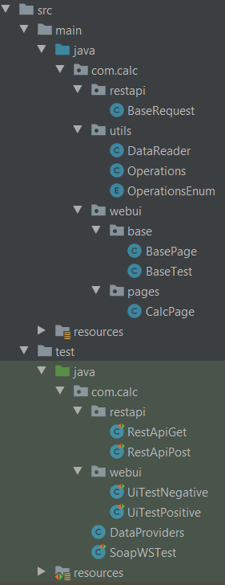For performance and load testing was used **Apache JMeter** <https://jmeter.apache.org/>. The Apache JMeter™ application is open source software, a 100% pure Java application designed to load test functional behavior and measure performance. It was originally designed for testing Web Applications but has since expanded to other test functions.

* 1. **Test automation project overview** 
     1. **UI and API testing**

*main.java.com.calc*

*restapi –* base class for Rest Api tests

*utils* – contains classes for reading test data from the Excel. Also contains enum and class for auxiliary operations.

webui – contains logic for UI tests

*base* – base classes for tests and pages

*pages* – page objects for the application.

Actually, the **testCalc** app has the only page, but this structure was created for easy extendibility.

*resources* – contains webdrivers executables.

*test.java.com.calc*

This package contains test classes for UI and Rest API. The SoapWSTest class is not fully implemented – unfortunately, I didn’t manage to send any SOAP request due to the lack of experience in SOAP API testing.

*restapi -* contains API tests using REST-assured library

*RestApiGet*

Containsparametrized tests for GET requests, also has tests with random values. Covered both positive and negative conditions.

*RestApiPostt*

Containsparametrized tests for POST requests, also has tests with random values. Covered both positive and negative conditions.

*webui –* contains tests for UI using Selenium Webdriver.

*UITestNegative* – parametrized tests for negative conditions.

*UITestPositive* – – parametrized tests for positive conditions.

*DataProviders –* class with static methods – TestNG data providers.

*resources* – contains Excel test data with PICT-generated test pairs.

* + 1. *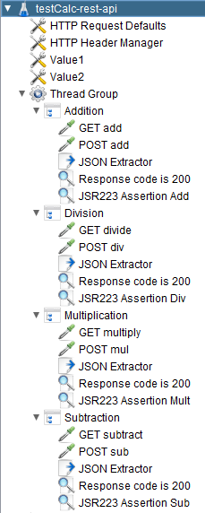***Performance testing**

For the performance testing used Apache JMeter tool. JMeter script *testCalc-rest-api.jmx* can be found in *test-jmeter* folder.

All requests use **random**-generated values for **Value1** and **Value2**. In case of performance testing using Excel data sheets is exhaustive.

* *HTTP Request Defaults* – has default URL for all requests. In our case it’s ‘localhost’
* *HTTP Header Manager* – default header for each request.
* *Value1* and *Value2* – random variables. Each value is regenerated for each new thread (user).
* *Thread Group* is a set of threads executing the same scenario. It is the base element for every JMeter test plan.
* *Simple Logic Controllers* – for each operation.

Each operation has GET and POST request, and additional elements:

* *JSON Extractor* to fetch the result of values calculation.
* *Response code assertion* – checks the response is OK
* *JSR223 Assertion* – checks the result of calculation.

To run tests from cm, launch the *run.cmd* file in the script root folder.

* 1. **Project settings**
     1. **Setup**

1. Installed Java, added JAVA_HOME to environment variables.
2. Installed Maven, added MAVEN_HOME environment variables.
3. Add M2 variable to path.
4. Installed the latest versions of Chrome and Firefox browsers.
5. Download <https://jmeter.apache.org/download_jmeter.cgi> and install JMeter.
6. Add <Jmeter folder\bin> to the PATH.
7. Download the project source code.
   * 1. **Run UI and API tests**

There are two three available ways to run tests:

1. Separately from the IntelliJ Idea.
2. Run TestNG configuration files from IntelliJ Idea:
   1. *crossbrowser-testng.xml*. It runs all UI tests against Chrome and Firefox in parallel.

***Note****:* Firefox is run in headless mode.

* 1. *rest-api-testng.xml.* It runs Rest API tests in parallel.

1. Run TestNG configuration files via Maven.

Run command *mvn clean test*. It runs suites *crossbrowser-testng.xml*

**WARNING!**

There are ~20 failed tests for UI and RestAPI. Fails are caused by Integer Overflow. I decided to keep this tests in case of developers fix this issue (joke).

* + 1. **Run JMeter tests**

Go to *test-jmeter* folder, launch run.cmd file (for Windows). The report is created after run.

Or just launch JMeter and open .jmx file.

* 1. **Test reporting**

**SureFire** report created after test run via Maven. It can be found here:

*test-automation\target\surefire-reports*

**JMeter** report can be found here:

*test-jmeter\reports\<timestamp>*

*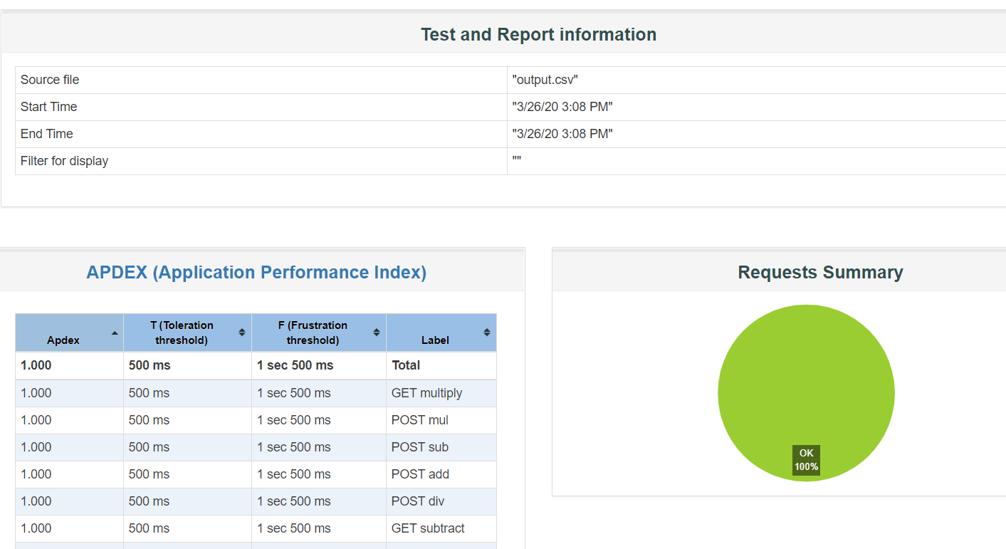Fig 2.4.1 JMeter report*

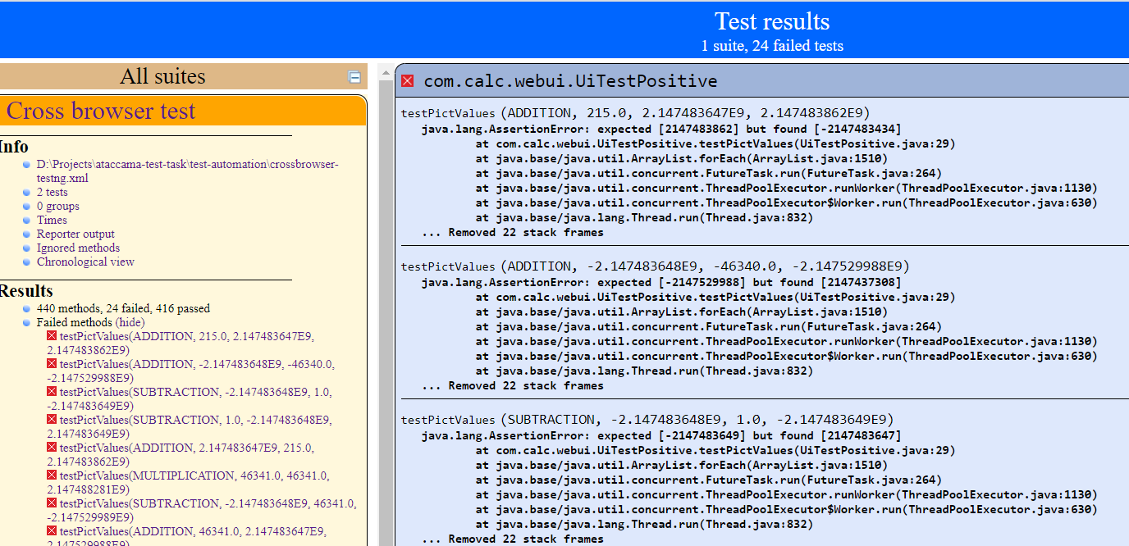

*Fig 2.4.2. SureFire report*